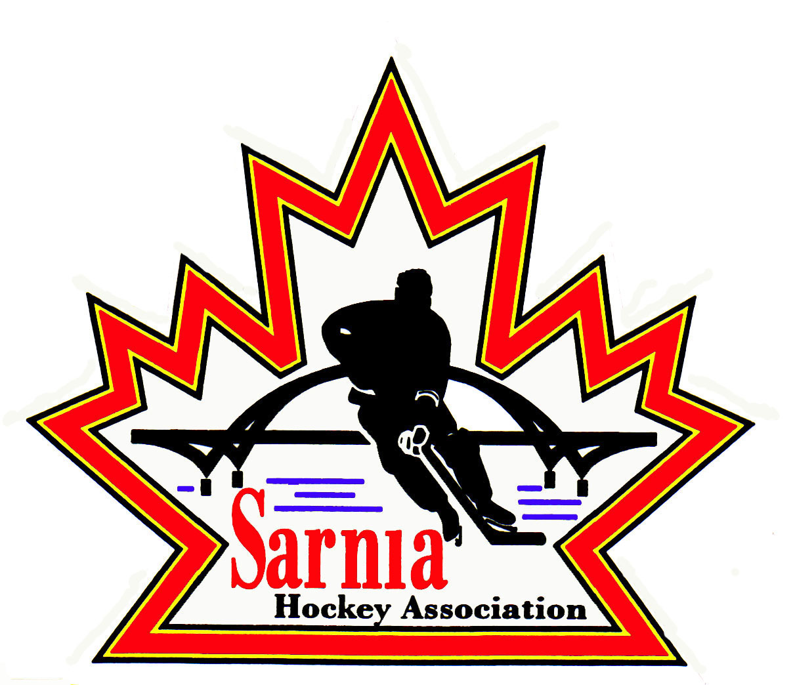

Sarnia Hockey Association

Minutes | Date: JuLY 17, 2024 | time 7:00 pm

Meeting called by | Paul Walsh, President
Type of meeting | Regular
Secretary | Kelly Lane, Recording Secretary

Welcome | Paul Walsh, President, and meeting Chair welcomed everyone and called the meeting to order at 7:10 pm.

ATTENDANCE | Heather Amaral, Andrew Beasley, Jacquie Beasley, Jerry Bernardo, Pat Forbes, Terry Gray, Dan Hunt, Kelly Lane, Linda Lauzon, Kyle Mellor, John Mellor, Jeffrey Needham, John Ritchie, Wayne Scarrow, Lesley Smith-Taylor, Kevin Taylor, Jason Teather, Barb Walsh, Paul Walsh  Regrets: Ian Dunn, Chuck Ewart, Emily Brown , Jeff Fogal, Bonny Marcy, Don McGugan, Ted Pendle, David Penner, Tim Turner

ACCEPTANCE OF MINUTES | MOTION #240717-001  “That the Minutes from July 2, 2024, be accepted as presented.” (Bernardo/K. Mellor)  Carried

TREASURER’S REPORT | No Report

BILLS TO BE PAID
  Recipient | Expense | Amount
  No Bills |  | $

PREVIOUS MEETING FOLLOW UP | POLICY 3.01:  - Approved to go through PRAC and that has been completed.  - Vice-President presented and reviewed the policy.  MOTION #240717-002  “To accept policy 3.01 as presented.” (K. Taylor/K. Mellor)  Carried  POLICY 2.03: COMMITTEES AND SUB COMMITTEES:  - There are members of the standing committees that need to be approved by the Board.  Executive Committee:  - Paul Walsh, Kevin Taylor, Kelly Lane, Wayne Scarrow, (Lifetime Member), Barb Walsh, Paul Walsh (Rep Director), Jerry Bernardo and Emily Brown  Nomination Committee:  - Paul Walsh, and 1 member selected by Board of Directors with 2 ballot scrutineers.  - Wayne Scarrow to remain.  - Scrutineers: Treasurer, Wayne Scarrow  MOTION #240717-003  “That Wayne Scarrow be accepted as a member of the Nomination Committee.” (K. Taylor/Needham)  Carried  Rec Steering Committee:  - Jerry Bernardo, and minimum of 3 directors  - Officiating, Ice Scheduler, Registrar, Darren Chevalier, Dan Hunt, Pat Forbes, David Pender appointed by Chair of the Committee.  Board of Reference:  - Chair will be either Vice Chair or Past President  MOTION #240717-004  “That Wayne Scarrow fulfill the duties of Past President.” (K. Taylor/J. Mellor)  Carried  Audit Committee:  - Two directors selected by Board of Directors.  MOTION #240717-005  “That Barb Walsh and Ian Dunn be nominated to the Audit Committee.” (L. Smith-Taylor/Forbes)  Carried  Budget Committee:  - Treasurer will be Chair and President is Vice Chair.  - Members are Kevin Taylor, Barb Walsh, Paul Walsh, Jerry Bernardo and any other directors appointed by the Chair.  AD HOC committees to be formed as needed. SHA Board would appoint members at that point.

REGISTRATION DIRECTOR | REGISTRATION REPORT:  - Point Edward Minor Hockey is putting a notice on their board and sending their U21 players to SHA. We believe there are 6 players at this point.  - Registrar is suggesting we put out a Facebook boost for the last two weeks of July before late fees start on August 1.  - Rep Rosters are on the go, and some have been submitted to the Alliance for review/approval.  - General misconception is that SHA is asking for all of the proof of address, qualifications etc. for Volunteer Registration, but it is the OHF/Hockey Canada requiring this information and SHA has to collect the information.
  DIVISION | REGISTRANTS
  Foundations | 94
  U6 /U7 | 81 (wait list cleared)
  U8/U9 | 133
  U11 | 136
  U13 | 141
  U15 | 127
  U16 | 55
  U18 | 45
  U21 | 12
  TOTAL | 824

REP TEAM VICE PRESIDENT | - There will be a mandatory Rep Coach/Manager meeting on July 22. One representative from each rep team needs to attend.  - Registrar, Treasurer, Equipment Director, Vice Chair Administration and Ice Scheduler will attend and provide a presentation of the key points to be discussed which can be sent out to the Coach/Manager so they have it as there will be a lot of information shared during the meeting.  - There will be another meeting for U8/9 and U18 for tryouts later.  - There are 9 teams that haven’t responded yet.

RECREATION DIRECTOR | - Heather Amaral was introduced and welcomed to the Board as a Member at Large for Special Events for Recreation Division. A meeting will be scheduled to further discuss the role.

U6/7 DIRECTOR | - For U6/7 on Saturday mornings there are 6 teams with 40 players on the ice at once. U6/7 Director is suggesting using the 7 am time slot to rotate teams through that ice slot.  - We will try to roster the Point Edward players to the same team if possible.

VICE PRESIDENT ADMINISTRATION | TEAM UNIFORMS:  - Rep teams may wear alternative uniforms and after Vice President Administration has reviewed the budgets, there are some teams that have budgeted for a third jersey.  - The third jersey has to be reviewed by the Board and the supplier of the jersey has to be an approved supplier of the Sarnia Sting.  - Vice President Administration had a discussion with Planet Stitch, and they do get the Sarnia Sting organization to approve the design. The Sting organization understands teams want to do this for fun but would prefer they wear their supplied jersey.  MOTION #240717-006  “That SHA approve a U13B tournament jersey as presented.” (B. Walsh/J. Mellor)  Defeated

ICE DIRECTOR | - 5 rep teams still have not provided their tournament dates: U18 A, U11B, U13 B, U15 B and Tier 1. If they don’t provide the tournament dates to the Ice Scheduler within the week there will be no changes made to the schedule.  - 7 blackout dates are approved so it is going to be challenging for scheduling games this year. First half of season ends November 24, and we have two big tournaments around that time (U17 Worlds Oct 28-Nov 10).  - Lengthy discussion about AAA Silver Stick tournament dates. Right now, Stars on Ice is taking Dec 5-8 at PASA 1. A meeting to be schedule so that SHA, the City and Sarnia Lambton Tourism can sit down to discuss. Our message is to remain consistent that Silver Stick is a yearly event and we already have collected money and received commitments from these teams for the December 5-8. Tourism Sarnia Lambton was aware last February of the dates.  - PASA 1 and PASA 2 are available, and we will start ice there Sept 3. Ice will start at Pat Stapleton on Sept 9 and Clearwater Red and Blue September 3.  - Pre-season from Sept 3 to Sept 27 and then start regular season on Sep 23 for practices.  - October 6 would be start for U16-21.  - Rep games will start Sept 30.  - Between Sep 3 and Sept 22, rep teams will get 2 practices and an ice slot on the weekend.  - U18 rep can start tryouts before Jr. C finishes.  - We usually do evaluation skates for U11, U9, and U7. Ice Scheduler will work with respective Directors on this.  - Prep skates will occur from Sept 3-7. Skills Director to organize the Instructors for these skates.  - Discussion about registration for Prep Skates which we have to offer them 4. 50 player maximum with 3 goalies. In the past we haven’t charged goalies. Goalies reach out to registrar directly to get registered for these sessions.  - Don’t have date set for it to open.  REC GAME SCHEDULING:  - Ice Scheduler is proposing that Rec games occur thru the week. With the blackout weekends, the Rec players may only get 17 games. Rec has already requested a black out for the Nazem Kadri tournament. We already do it for U15 division, and it has worked out.  MOTION #240717-007  “That that SHA adopt the ice schedule for the 2024/25 season to have Rec U11 to U15 games played through the week.” (Lauzon/Bernardo)  Carried with 1 abstained.  - This was previously rejected as we didn’t have all of the information.  - U8/U9 would be on Friday night. Black out dates would affect them.  - U9 have games on the weekend as we don’t have two sets of cross ice boards.  - Discussion about final days occurring the week of March 24-28 in order to give them an extra week. We could check with the City as AAA are doing a Face Off Tournament last week of March. Alliance Championships are early this year, so we need to ensure we have a buffer time to allow teams to book hotel etc. for Alliance Championship. Further discussion to occur.  - Having games through the week could provide more opportunity for Skills on the weekends.  - There was a concern that U16B would be going to 10:45 pm at night. The other practice ends at 10.  - U11 and U13 play their games on weekdays.  - The ice schedule is pretty close to last year’s schedule. It allows for teams to AP players except for U9.  - Refs – U18 is always going to be an issue in getting referees on Sunday’s. There was a question about younger referee availability (level 2) by moving games to weeknights.  - Weekend ice hasn’t changed as blocks stay the same.  NEXT STEPS: Prep skates to be scheduled and then ice schedule will be populated.

CLINICS DIRECTOR | - There are several Lady Sting coaches that have registered for the D1 Clinic. It is not full yet, and it is open to other Associations. Alliance is reaching out to other centres. We need 2 teams to be involved.  - We may get more from Sarnia Lady Jr Sting.

CORRESPONDENCE | - Received a telephone call from the City and officials from Sarnia Skate want to meet with SHA, They have concerns about when they have ice before us on Sundays. Visiting teams do warm up on the top of Pat Stapleton with loud music blaring. Sometimes boys come out and watch. Skate Sarnia has complained to the City, but it is a public facility. Skate Sarnia has asked us to meet to discuss.  - A big concern is the choice of the music and the language which is inappropriate with young kids on the ice.  - We need to bring some coaches to the meeting, and this could be addressed at the upcoming Coach’s meeting. Linda Lauzon and Terry Gray to attend.

NEW BUSINESS | VOLUNTEER REGISTRATIOIN AND VSC SUBMISSION:  - Reminder to complete this and links to be sent out again.  NEXT MEETING:  - Next meeting is Tuesday, August 6, 2024, at 7:00 pm at Clearwater Arena Lower Hall.

adjournment | MOTION #240717-008  “That the meeting be adjourned.” ( Scarrow/K. Mellor)  Carried

Paul Walsh Kelly Lane
President Secretary

